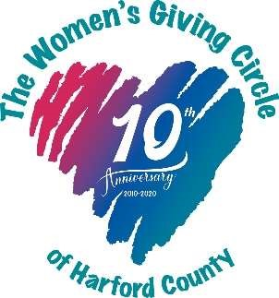

Women’s Giving Circle of Harford County 2023 Grant Awards

Total Awarded = $54,724.00

Chesapeake Therapeutic Riding, Inc. - $3,849
This grant will cover the cost of (1) Micro Rain M25 water wheel. This device will reduce the amount of dust in the air, making riders and volunteers more comfortable.

CASA of Harford County - $5,000

Tutoring services will be provided for children currently being served by CASA of Harford County.

The HOPE Center of Maryland, Inc - $3,000

The Beyond Blessings Program will provide 75 low-income students with a backpack filled with shelf-stable meals to ensure students do not go hungry over weekends and during the holidays.

Homecoming Project - $5,000

A Life Skills Group will cover the cost of a 20-week life skills group. Each group will include 8 participants and 1-2 licensed counselors.

Girls on the Run of Central Maryland - $5,000

The Harford County Expansion Initiative will allow GOTR to grow participation among Title 1 schools in Harford County. Additionally, they will purchase running shoes for any participant in need.

Boys and Girls Club of Harford and Cecil Counties - $5,000

Grant funds will be used to run a summer camp that is designed to promote and sustain learning in youth of all ages during the summer months.

***The Forgotten Initiative, Harford - $2,000
This grant will be utilized for a weekly life skills class for transitional children (ages 14-21) in foster care. The classes will teach cooking, how to prepare a resume, how to find affordable homes, financial literacy, and will help to identify career goals.

The Sexual Assault/Spouse Abuse Resource Center - $5,000

This funding will allow SARC to purchase new car seats, strollers, and bedding for the Phelan Safehouse and will provide childcare and ride share assistance.

The Sharing Table - $5,000

Weekly meal and grocery distributions will be provided to those in need in the Edgewood community.

Harford County Family Assistance Fund - $1,375

To ensure a smooth transition when entering out-of-home care, this grant will provide luggage to 25 children so that no special items are left behind.

Improving Education - $5,000
The Bedtime in a Box program will provide low-income families with books and healthcare materials to establish a nightly routine that supports their child’s health, sleep and early learning. Each box will have 4 age-appropriate books, bath wash, a towel, bath toys, toothbrush, toothpaste, pajamas, a stuffed animal, alarm clock, learning kit, and a kid-friendly routine log.

LASOS, Inc. - $4,500
This funding will cover the cost of renting the Bel Air Armory on Fridays. This will allow LASOS to run their camp 5 days per week over the summer. Those being served by the camp are children aged 4-21 who are enrolled in school in Harford County who do not speak English as their first language.

***Coming of Kings - $5,000
This weekly mentoring program will meet each Sunday from 1-3 p.m. The program will include speakers and field trips with a focus on leadership development, college preparation, and work readiness.

(*** indicates first time recipients)

